HR – Absenteeism Data Analysis

***Wireframe Documentation***

Homepage

As per the problem statement, we have divided analysis into three sections: -

# Impact of Absenteeism over the year in every department:

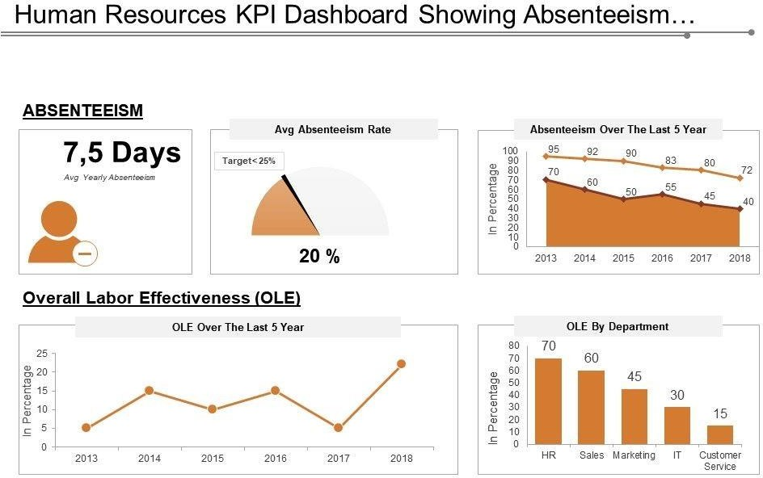

In this section we designed our first dashboard and tried to interpret the followings

* + Relation between absent hours and department.

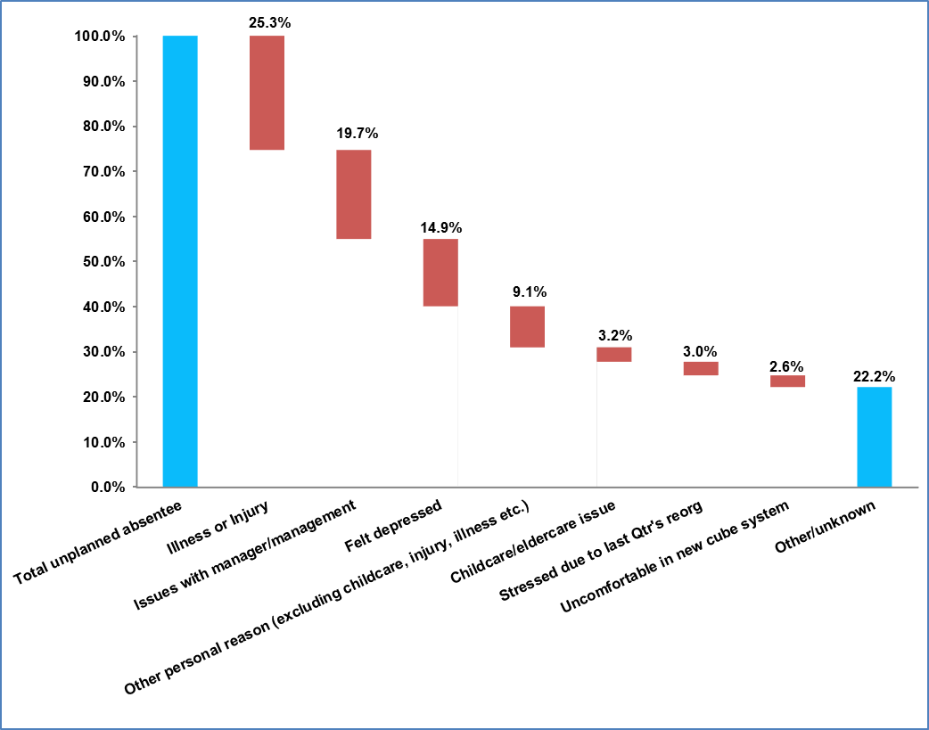

* + Relation between absent hours and cities .

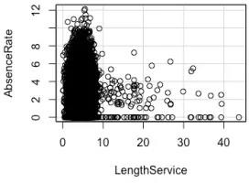

* + - What is its rate of absenteeism?
    - The absence rate is 2.9.

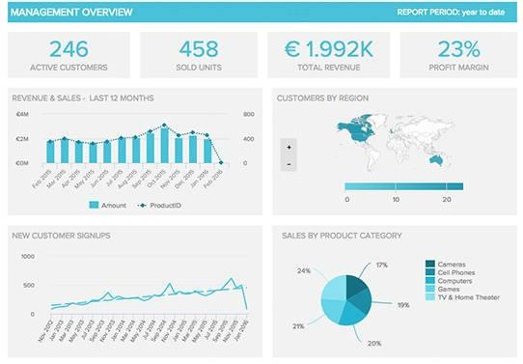

# Influence of Absent hours

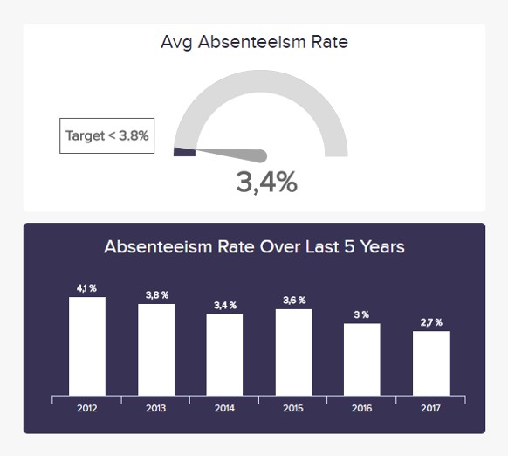

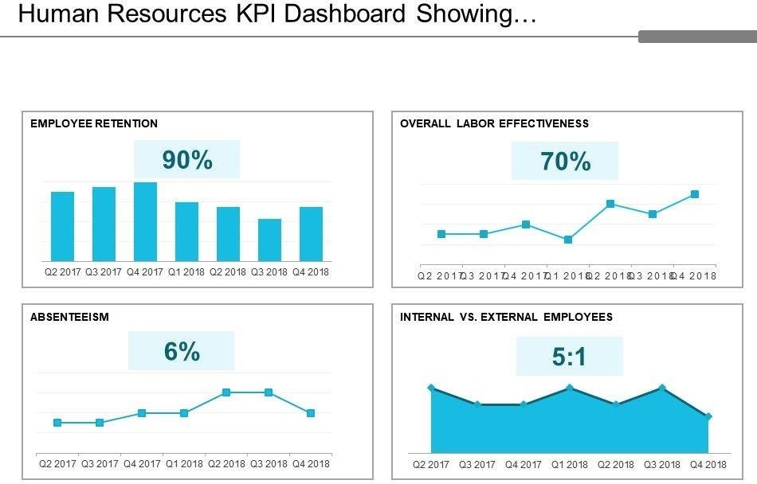

Here, we have our second dashboard and interpret the followings--

* + Distribution of Absent Hours across the Cities

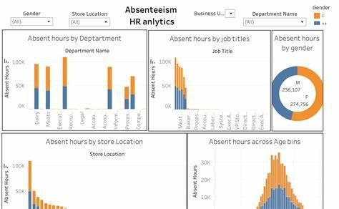

* + Relation between category and count of Cities



* Relation between Job type and Age and Absent hours.

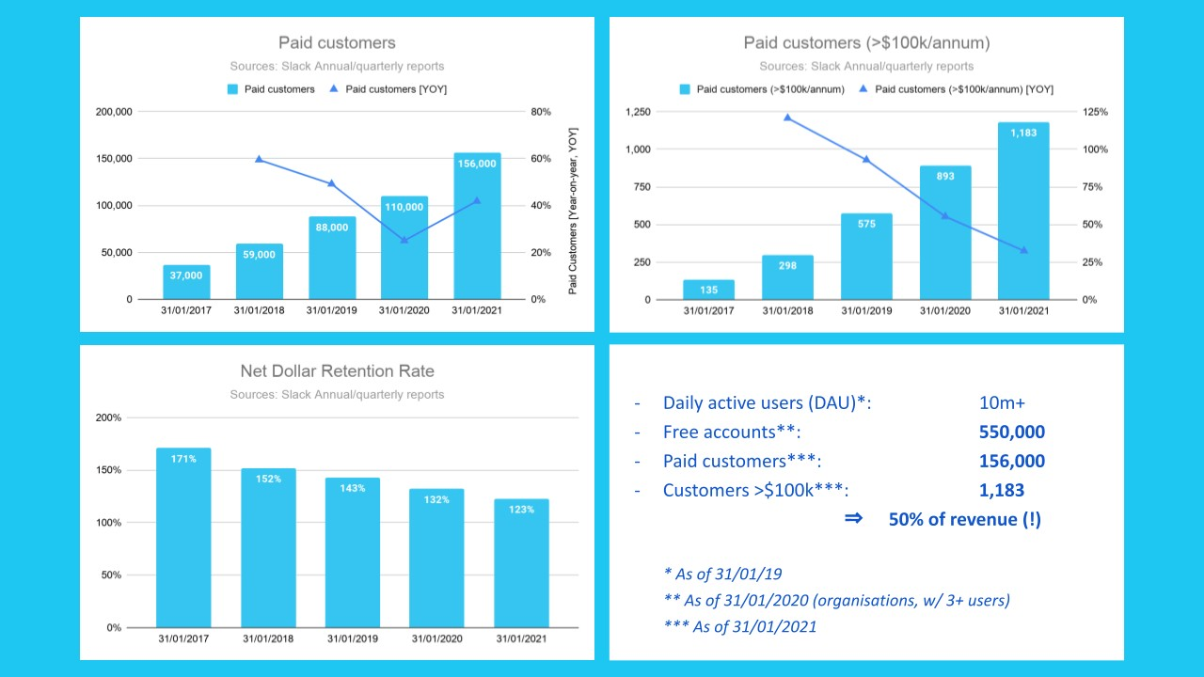

# In Dashboard 3, we tried to show other metrics on Hours.

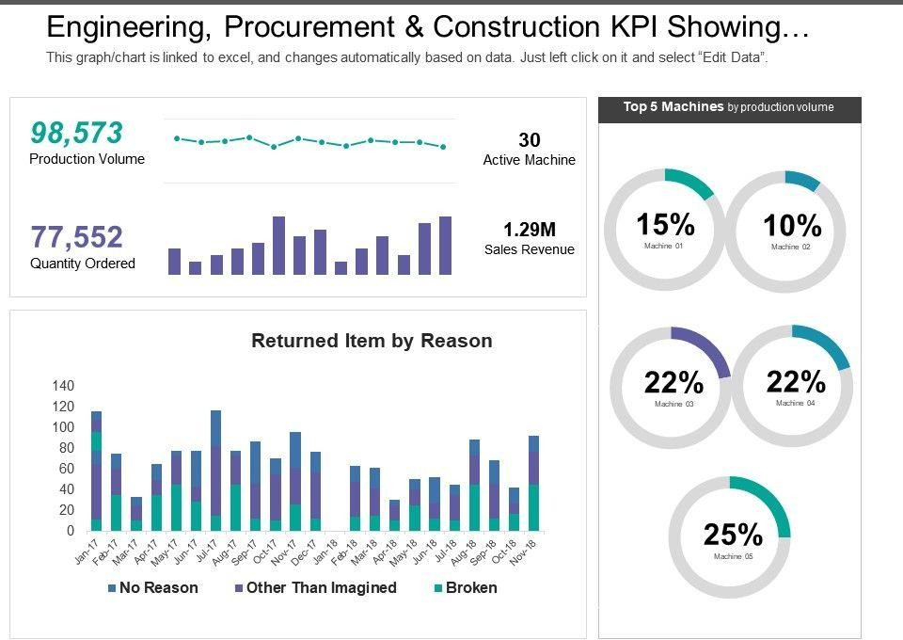

* + 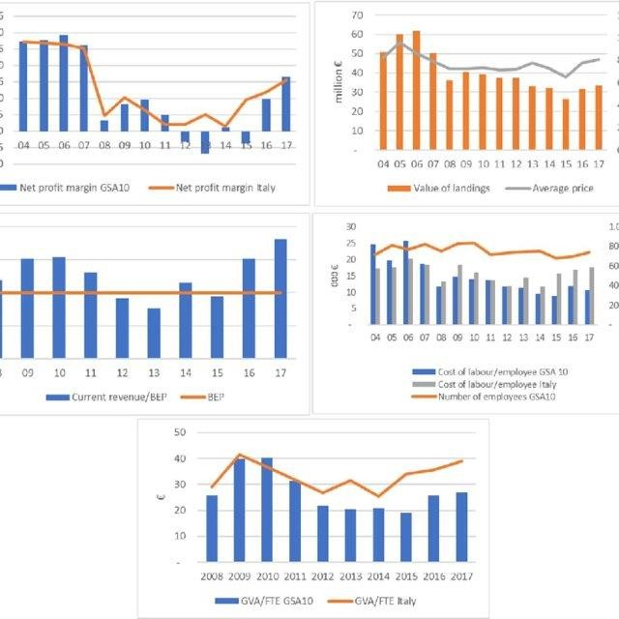Relation between Age and Department name.
  + Relation between Average Housing Price and DistMarket Parameter

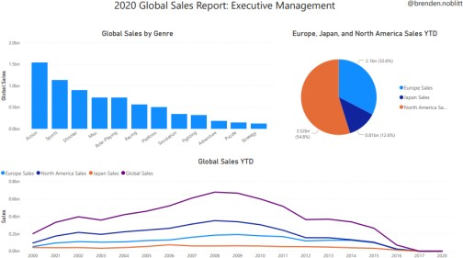

* + Relation between Average Housing Price and Carpet Area

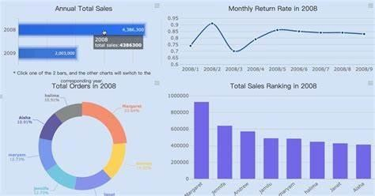

**Finally,** Min, Max & Avg Housing Price Comparison across the categories

